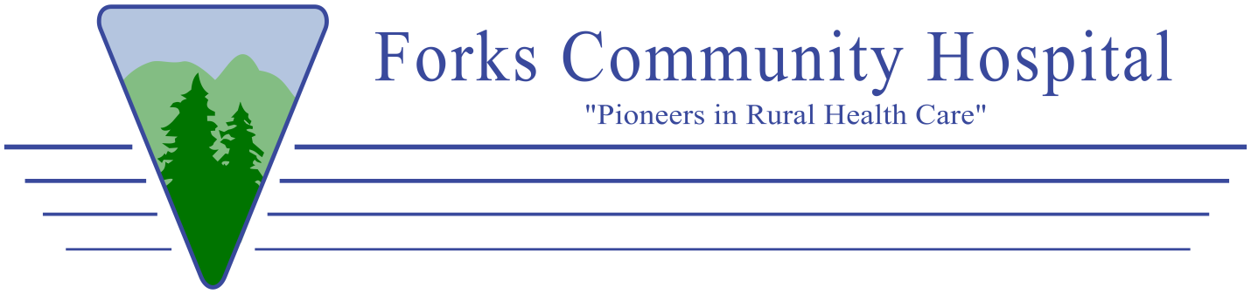

**Forks Community Hospital Patient and Family Advisory Council Plan**

Forks Community Hospital’s Patient and Family Advisory Council’s purpose is to improve the patient experience and the overall safety and quality for patients. This council will consist of hospital leadership staff, board and community members who have either been a patient or have had a close family member as a patient.

**Patient and family advisors can offer:**

* Insights about hospital strengths and areas where changes may need to be implemented
* Patient/Family perspectives into areas of planning, delivering, and evaluation of care
* Feedback on patient experiences.

**The intended benefits of the Council are:**

* Improved quality of care for patients
* Increase in patient loyalty
* Better health outcomes for patients
* Increase in patient/staff satisfaction

The Patient and Family Advisory Council (PFAC) will meet monthly (excluding December) via an in-person or virtual meeting. This council will be a formal group that meets with staff from within the organization, to advise on policy, program decisions, and practices. It is important for members to know that this is not a grievance committee. The advisory council is encouraged to work together to identify areas/opportunities for improving the patient and family experience. To keep the perspective of the PFAC fresh and patient-oriented, the maximum term of any patient/family member will be 2 years. The council will be a mixture of these 1-2 year terms. In addition, there will be an expectation of each member to attend at the least 80% of scheduled meetings. There is no decision-making authority vested with this committee. The PFAC is an advisory council only and will make recommendations to the Forks Community Hospital leadership. A summary of PFAC’s opinions/activities/meeting minutes will be submitted to the Director of Patient Safety and Quality for the Performance Improvement Committee. In addition, any pertinent information will be passed on to the Board of Directors by the board member representative(s) on this council.

PatientandFamilyAdvisoryCouncilPlan.FCH8360.20220621